**CHAPTER III**

**Operational Framework**

**3.1 Methodology of the Study**

Methodology is the systematic, theoretical analysis of the methods applied to a field of the study. It compromises the theoretical analysis of the body of methods and principles associated with a branch of knowledge. Typically, it encompasses concepts such as paradigm, theoretical model, phases and quantitative or qualitative techniques.

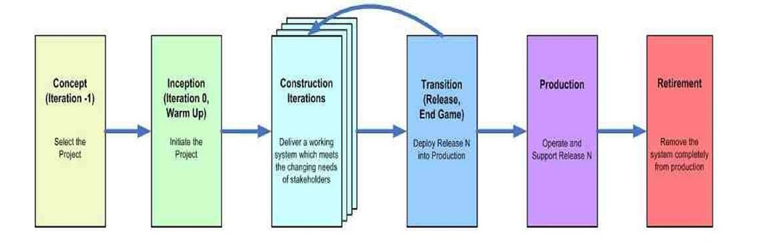Agile Software Development (ASD) is a software engineering framework that promotes iterative development throughout the life-cycle of a project and provides a close collaboration and constant communication between the development team and the business side.

Figure 3.1. Agile SDLC

Agile is an iterative, team-based to a deployment. This approach to a deployment emphasizes the rapid delivery of an application in complete functional components. Rather than creating tasks and schedules, each sprint has a defined duration (usually in weeks) with a running list, planned at the start of the sprint and prioritized by business value as determined the customer.

As work is completed, it can be reviewed and evaluated by the project team and customer, through daily builds and end-of-sprint demos. Agile relies on a very high level of customer involvement throughout the project, but especially during these reviews.

Generally, Agile methodologies promote a project management process that encourages frequent inspection and adaptation. This leadership philosophy encourages teamwork, self-organization, and accountability. Agile combines a set of engineering best practices (allowing for rapid delivery of high-quality software) and a business approach (aligning development with customer needs and goals). The proponents used the Agile Software Development Life Cycle (SDLC) framework for the development of the new proposed system.

The Agile SDLC is highly collaborative, iterative, and incremental structure in which the roles that people take are much more robust than on traditional projects. In the traditional world a [business analyst](http://www.agilemodeling.com/essays/businessAnalysts.htm) creates a [requirements model](http://www.agilemodeling.com/essays/agileRequirements.htm) that is handed off to an [architect](http://www.agilemodeling.com/essays/agileArchitecture.htm) who creates [design](http://www.agilemodeling.com/essays/agileDesign.htm) models that are handed off to a coder who writes programs that are handed off to a [tester](http://www.ambysoft.com/essays/floot.html) and so on. On an Agile project, developers work closely with their stakeholders to understand their needs; they pair together to implement and test their solution, and the solution is shown to the stakeholder for quick feedback. Instead of specialists handing artifacts to one another, and thereby injecting defects at every step along the way, Agile developers are [generalizing specialists](http://www.agilemodeling.com/essays/generalizingSpecialists.htm) with full life-cycle skills.

**3.1.1 The nature of Agile SDLC is described in its six phases:**

1. **The Concept Phase: Pre-Project Planning**

The proponents have identified a company based in Canada that needed a system, and the owner and one of the proponents had a Facebook Messenger meeting regarding the problem. When contacted by the proponents, the owner said: “I need to improve my business and make it easier and safer for the files “. In order to address this problem, the proponents developed an Online Patient Portal with Secure Socket Layer and Human Resources Forecasting, and automate the company’s data input process that provide an accurate and secure information system regarding its patients.

The proponents had a Survey on 10 companies where it’s related on the system. It gathers information on 10 companies, how frequently do patients come to their clinic, what sort of problem do the patients present with, at what age do your patients come in for consultation, do they need to start therapy or not, what is the typical duration of the therapy, how do you record patient data when they first arrive during follow up, how do you monitor indicators like vital signs after therapy, what is your current system for scheduling appointments including for follow up, is there a problem with patients not showing up on the schedule date/time of therapy and or follow up and lastly how much is the cost of the patient for the therapy / consultation. The details provided on the figures are the results of the surveys.

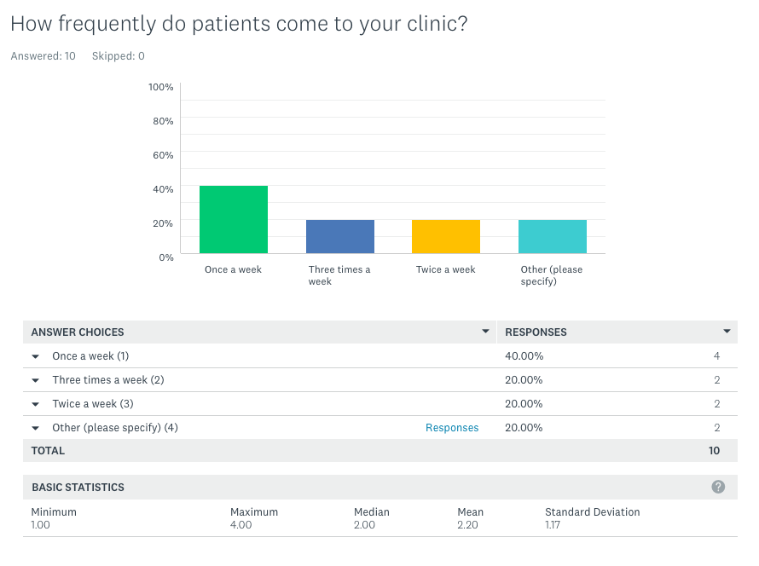Figure 3.2 Survey Question No. 1

According to Figure 3.2 results of the survey question no. 1, Out of 10 companies 40.00% of the respondents go to their clinic once a week, while 20.00% go three times a week, 20.00% as well go twice a week and lastly 20.00% of 10 companies responds others once a month.

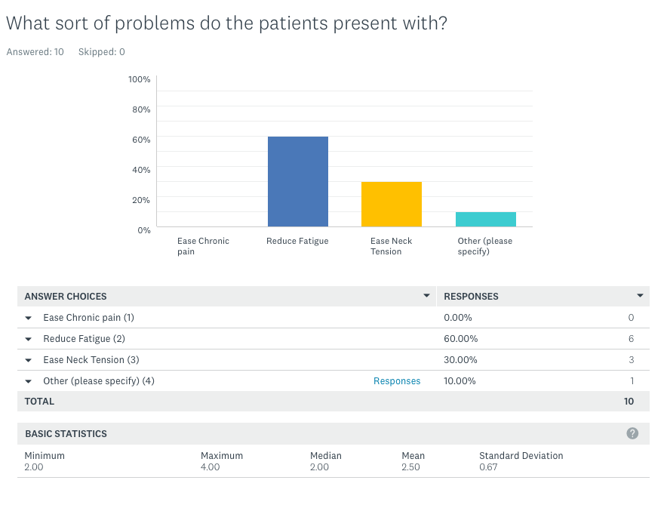

Figure 3.3 Survey Question No. 2

According to Figure 3.3 results of the survey question no. 2, Out of 10 companies 60.00% of the respondents to reduce their fatigue, while 30.00% ease neck tension, 10.00% body ache and 0% of 10 companies responds ease chronic pain.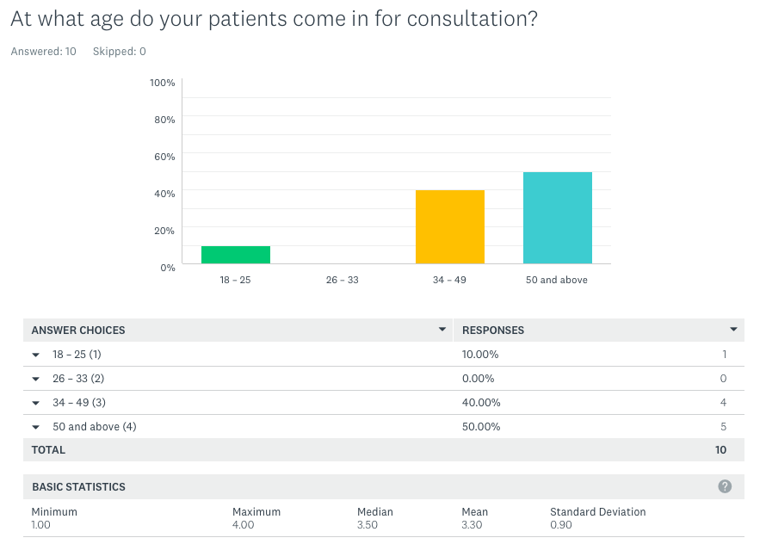

Figure 3.4 Survey Question No. 3

According to Figure 3.4 results of the survey question no. 3, Out of 10 companies 10.00% of the respondents age range 18 to 25 of their patients, while 40.00% 30 to 49, 50.00% 50 and above 0% of 10 companies responds nothing on 26-33.

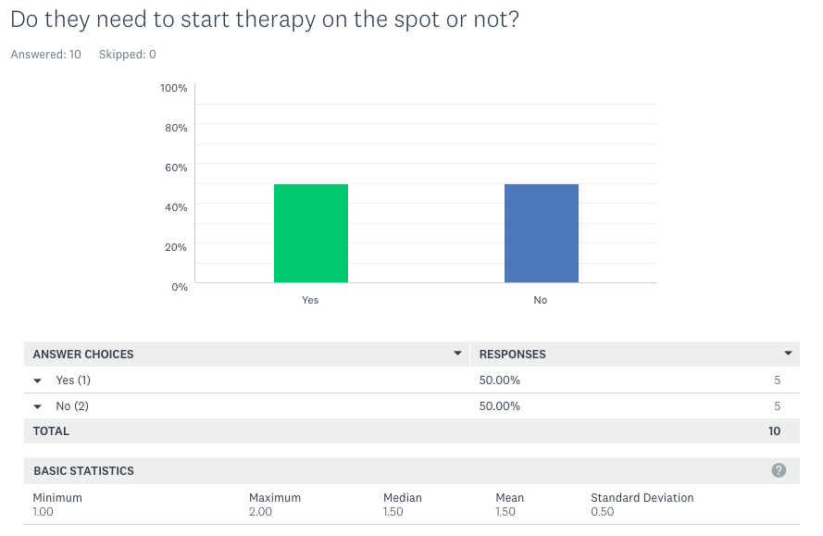

Figure 3.5 Survey Question No. 4

According to Figure 3.5 results of the survey question no. 4, Out of 10 companies 50.00% of the respondents says Yes, while 50.00% says No.

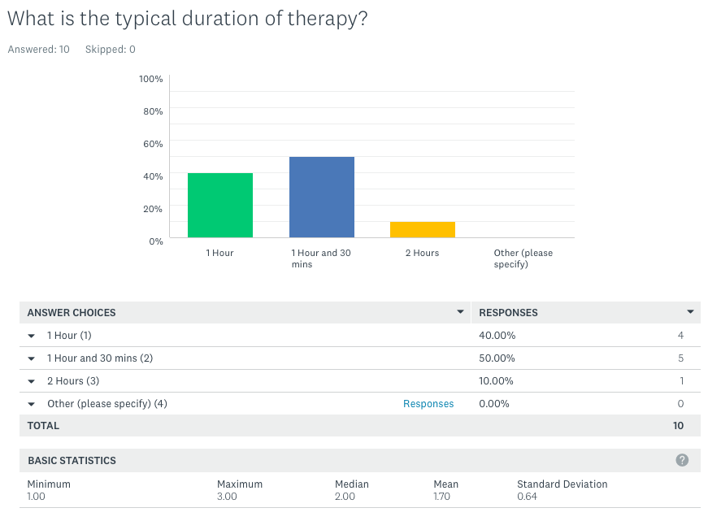

Figure 3.6 Survey Question No. 5

According to Figure 3.6 results of the survey question no. 5, Out of 10 companies 40.00% of the respondents says 1Hour, while 50.00% 1Hour 30mins, 10.00% 2Hours and 0% of 10 companies responds nothing.

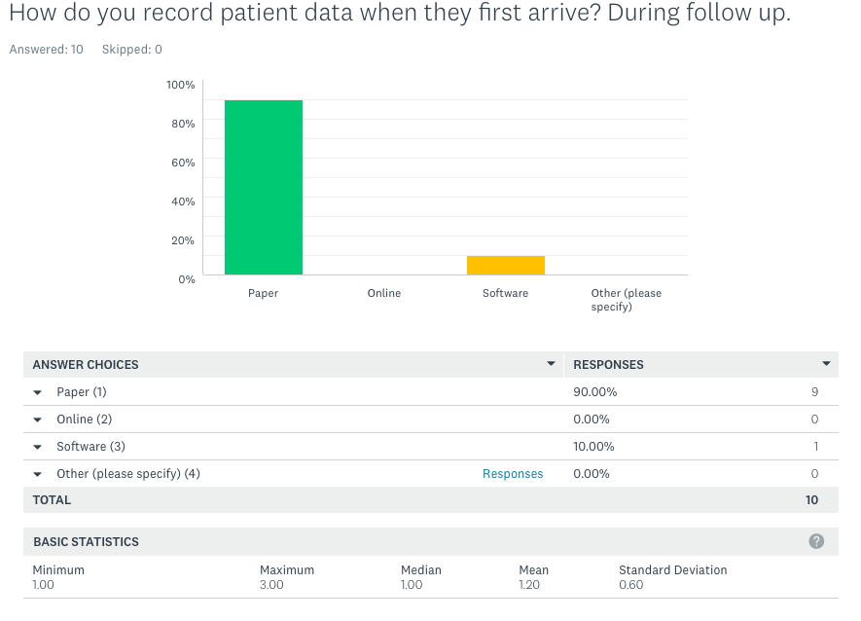

Figure 3.7 Survey Question No. 6

According to Figure 3.7 results of the survey question no. 6, Out of 10 companies 90.00% of the respondents says they are using paper, while 10.00% says they are using software, 0.00% Online and 0% of 10 companies responds nothing.

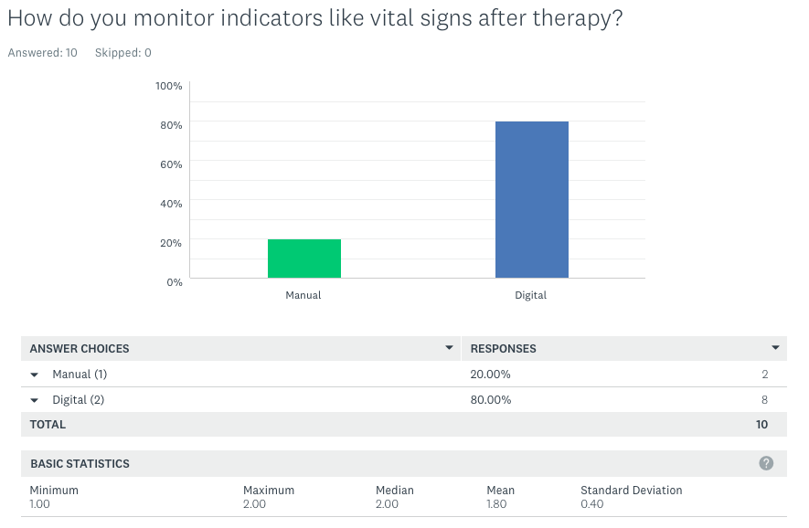

Figure 3.8 Survey Question No. 7

According to Figure 3.8 results of the survey question no. 7, Out of 10 companies 20.00% of the respondents says Manual on checking vital sign, while 80.00% says their using Digital 0.00% 2Hours and 0% of 10 companies responds nothing.

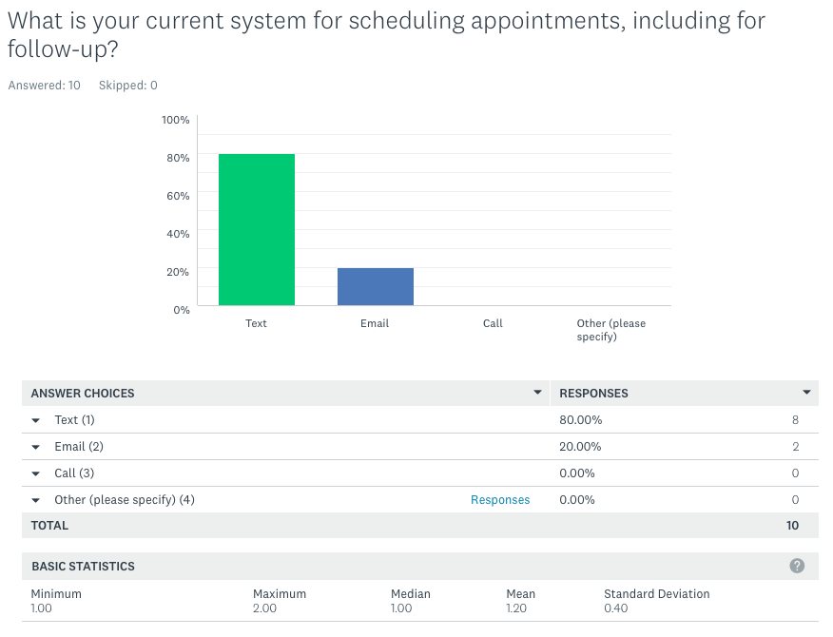

Figure 3.9 Survey Question No. 8

According to Figure 3.9 results of the survey question no. 8, Out of 10 companies 80.00% of the respondents says they’re using Text to communicate to their customers, while 20.00% says they’re using Email, 0.00% for calls and 0% of 10 companies responds nothing.

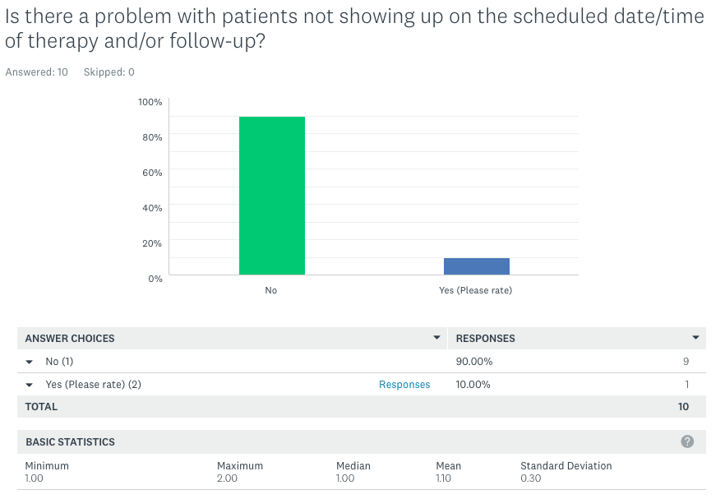

Figure 3.10 Survey Question No. 9

According to Figure 3.10 results of the survey question no. 9, Out of 10 companies 90.00% of the respondents says there’s no problem with patient not showing up on the schedule date/time, while 10.00% says Yes, 10.00%.

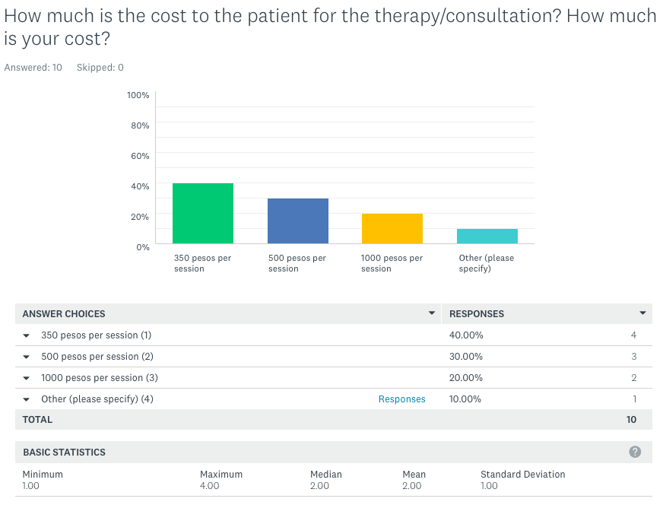

Figure 3.11 Survey Question No. 10

According to Figure 3.11 results of the survey question no. 10, Out of 10 companies 40.00% of the respondents says 350 pesos per session of therapy, while 30.00% says 500 pesos per session, 20.00% says 1000 pesos charge per session and 10% of 10 companies responds 1500 / others. After the data gathering through the 10 companies, the proponents are able to predict how the business will improve.

1. **Inception/Warm Up: Project Initiation**

The proponents asked the owner of the company to have a meeting with the chief programmer and to explain his business flow. On the agreed date, the information was gathered regarding how the company gathered input data, including the set-up of the work and how the patient and therapist interact with each other.

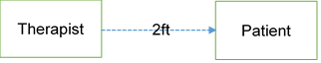

Figure 3.2

Figure 3-2 shows the physical set-up the company has in their Information Department. The Therapist is 2 feet away from the patient while interviewing and gathering information from the patient.

The proponents developed online website that process and simplify the registration of the company’s clients/patients. The proposed system also has a feature to schedule appointments and reminder to its users via Short Messaging Service (SMS) Notifications. The system employs a method for assuring the security of the system using Transport Layer Security and Secure Socket Layer Protocols’ and applied the Open Web Application Security Project (OWASP) Top 10 to the system. The system has a fingerprint scanner as part of system security. Each of the proponents was designated to a different task as follow Lead Coder, Project Manager, and Logistics respectively. The Project Manager will manage the whole project, scheduling and ensuring alignment to the thesis guidelines.

Prevailing processes discussed with the chief programmer to help in the creation of analysis and system design. Based on the analysis made and with the additional functions conceptualized, the proponents where able to produce the ERD and Context Diagram for the Online Patient Portal with Fingerprint Verification and SMS Schedule Reminder.

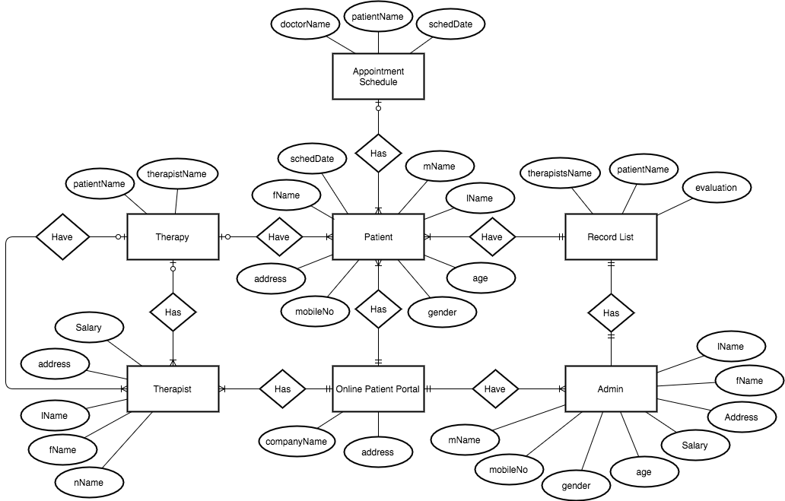

Figure 3.5 Entity-Relationship Diagram

Figure 3.5 Illustrates the analysis-produced for the logical structure of the system’s flow. The proposed system has 7 Entities. The Patient entity has 8 attributes: fName, mName, lName, age, gender, mobileNo, address and schedDate. The Admin entity has 8 attributes: fName, mName, lName, address, Salary, age, gender and mobileNo. The Online Patient Portal entity has 2 attributes: address and companyName. The Therapist entity has 5 attributes: address, fName, mName, lName and Salary. The Record List entiry has 3 attributes: therapyName, patientName and evaluation. The Therapy has patientName and therapistName. The Appointment Schedule entity has 3 attributes: doctorName, patientName and schedDate.

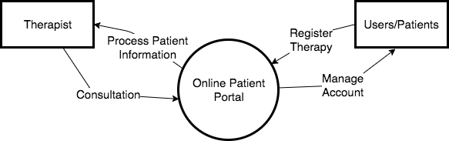

Figure 3.6 Context Diagram

Figure 3.6 shows the context diagram of the proposed system. People with direct access to the system, where identified and each of their functional boundaries was determined. The environment to be used was discussed and agreed with the company owner. The deliverables iteration of the software was introduced during the proponents meeting, after conducting the system analysis.

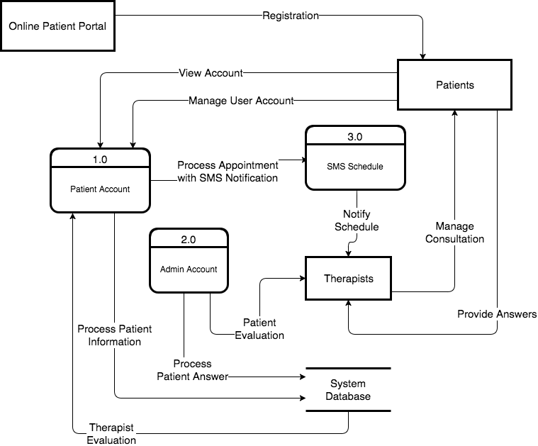

FIGURE 3.7 Data Flow Diagram Level 0

Figure 3.7 Illustrates the details and component of the system thereby providing a comprehensive view of the processes involved in the business function. The Web Based System is registered by the patient and manages the account saved through the system database and processes appointments with SMS Schedule. The next step is Notify the Therapists and Manage Consultation of patients. Then evaluate the patient answers being saved through the system database. At that point, it is ready to be viewed by the patient and can manage his/her account for the progress of the ongoing therapy.

The system to be developed will display a dashboard depending on the user role. The Online Patient Portal with SMS Schedule Reminder generates data in the system via registering online and confirmation through SMS which will be giving further details from the schedule given by the therapist. The system will have arranged the file on a First-Come-First-Serve basis and assigned each job depending on the availability of the therapist. Once this is done, the therapist will next process for the consultation. Then the patient will get a confirmation via SMS. Once done with the consultation therapist will evaluate reports based on the information given by the patient and received by the system. The system will be using single registration through web and one-client-side server for the patient information and it will be encrypted.

**System Flow Chart**

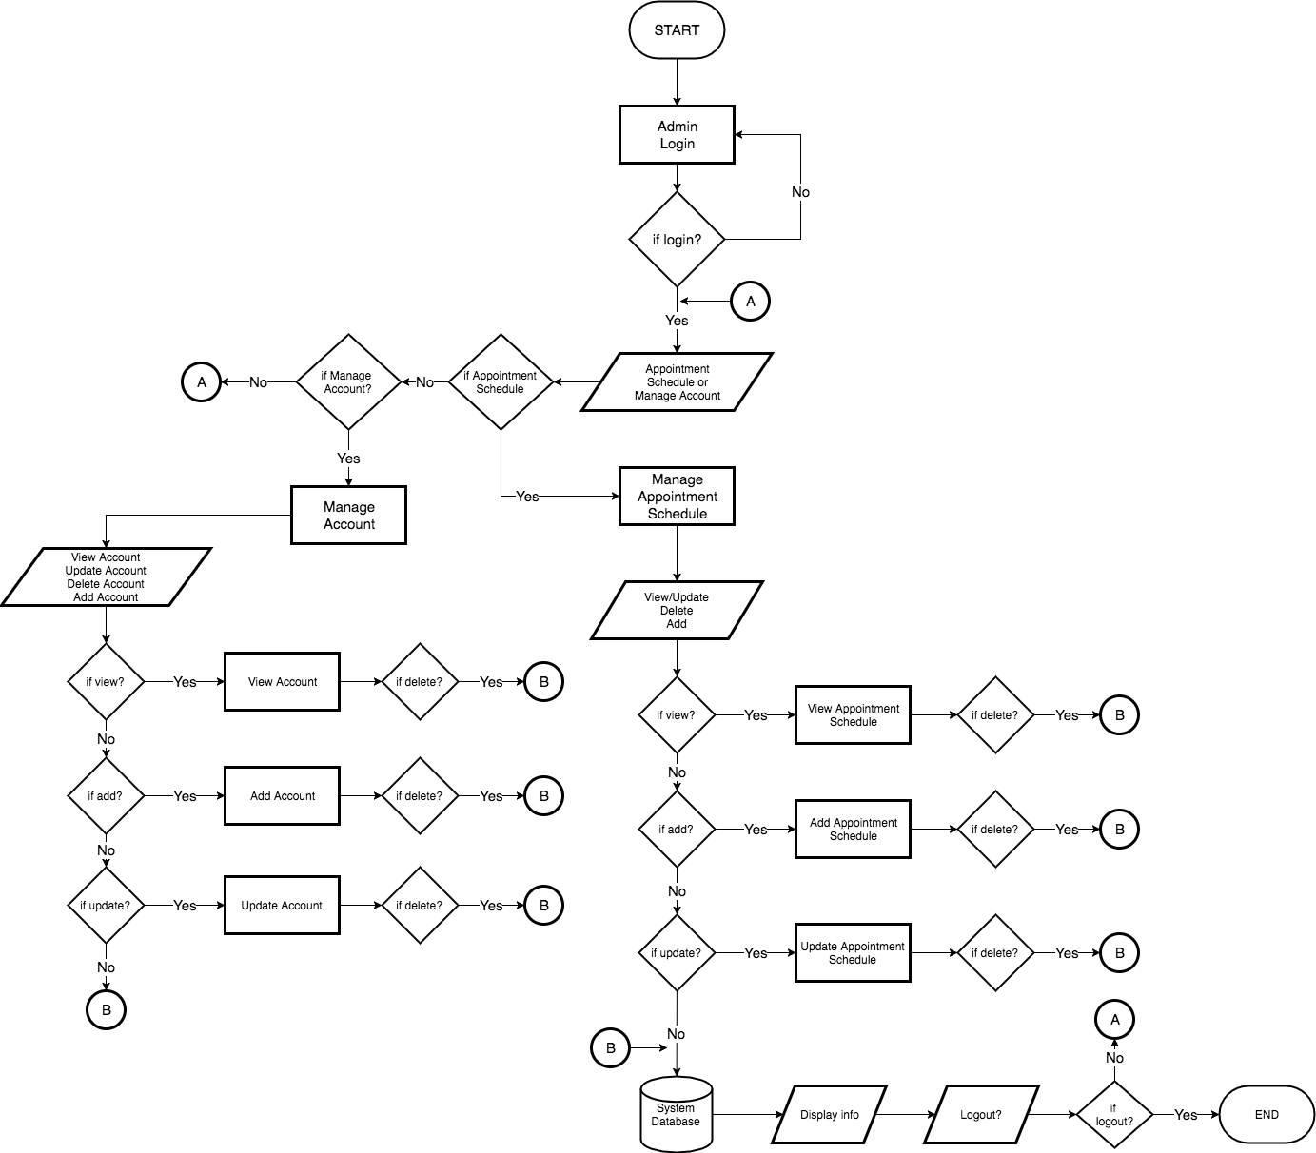There are three types of users in the system: administrator, therapist, and patient. The following sections of this chapter that represent the process flow diagram for each user in detail.

Figure 3.8 Flow Chart for Administrator

In Figure 3.8, the administrator of the system needs to login to enter into this system then go to the Admin site where Administrator can view Patients and Therapists Account and can create an account, add a new schedule, and delete, view, or update an appointment schedule.

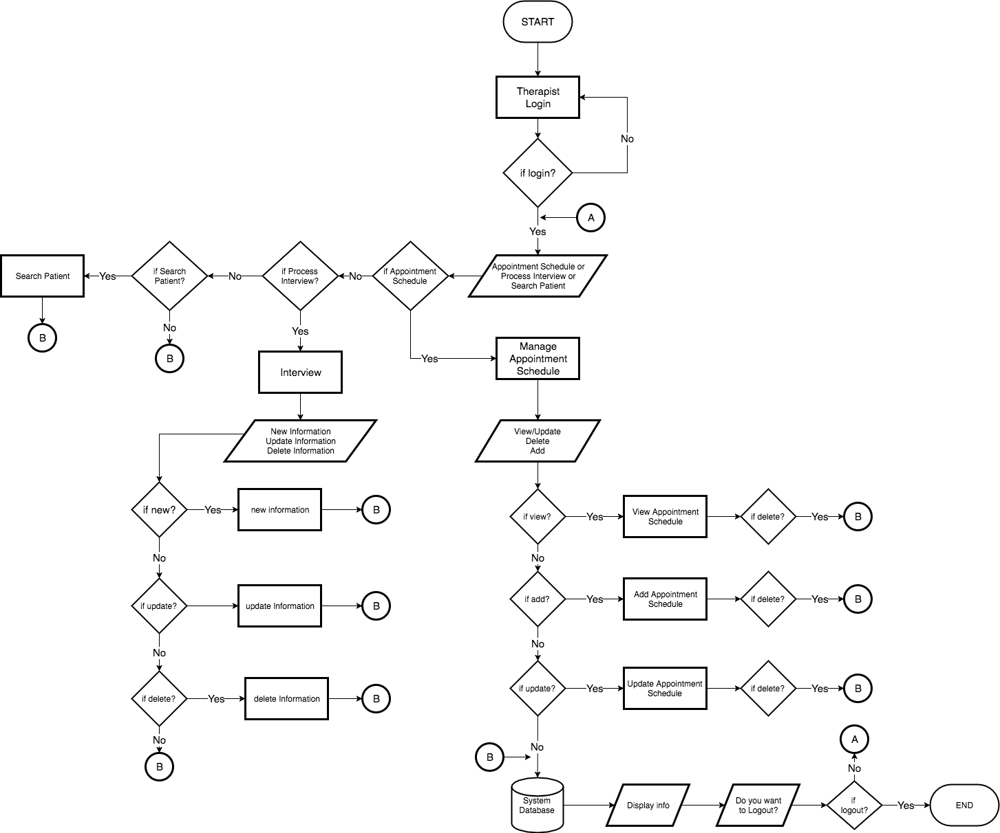

Figure 3.9 Flow Chart for Therapist

In Figure 3.9, the therapist must log in to view his/her profile and patients who have requested to schedule an appointment and the therapist’s schedule of appointments. After the therapist views a profile where, can update the profile information that needs to be modified and accept, reschedule appointments based on his/her availability.

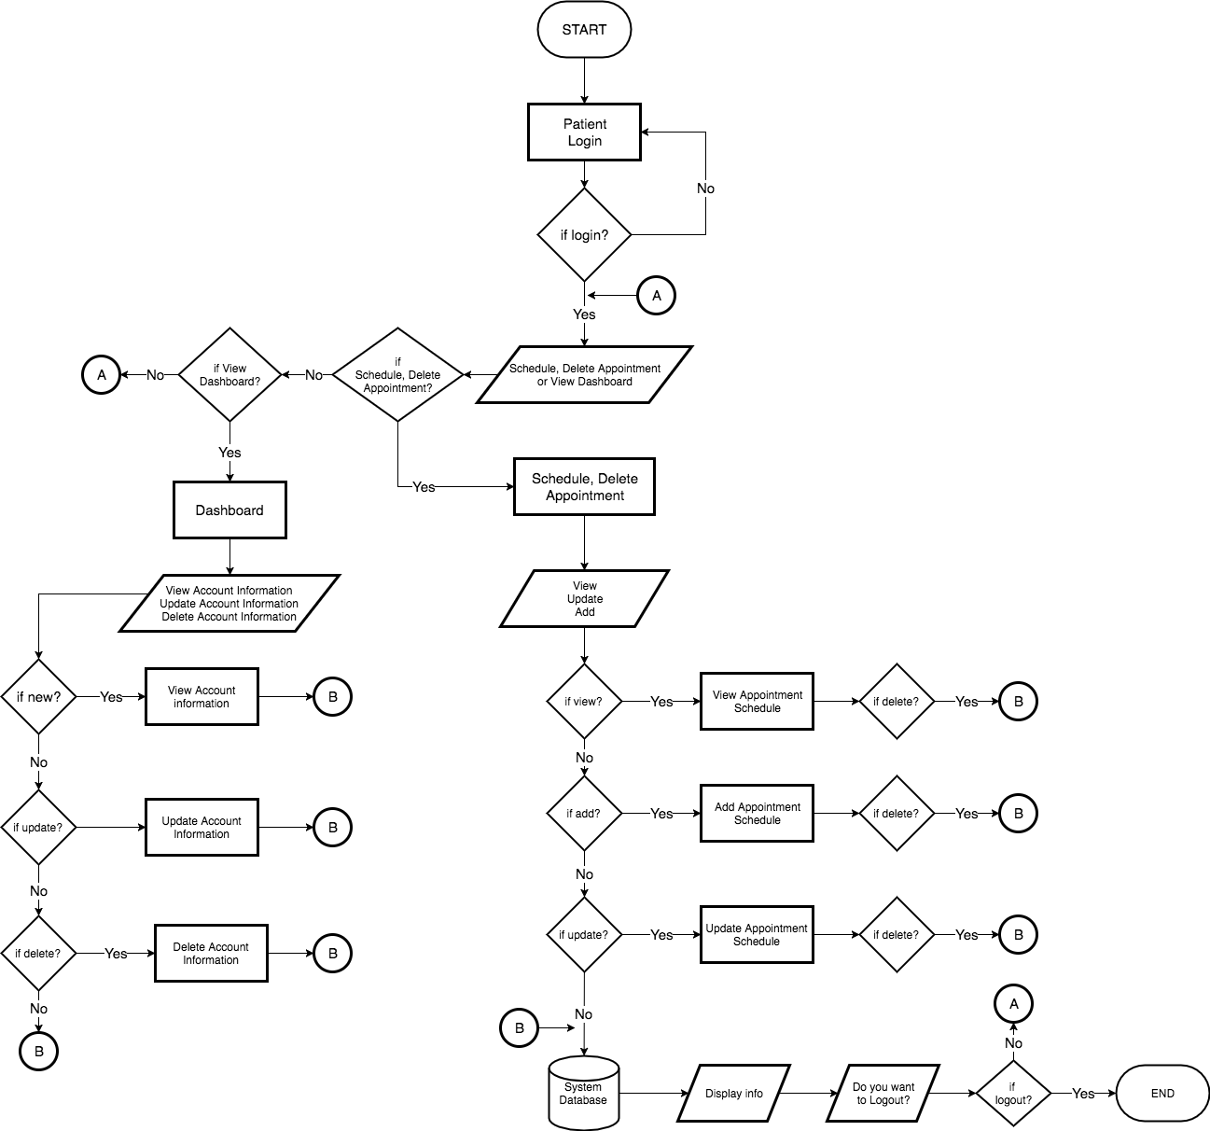

Figure 3.10 Flow Chart for Patient

In Figure 3.10, the patient must log in to view his/her profile and schedule an appointment. Thereafter, the patient can update his or her profile information if it needs to be modified. Then the patient can re-schedule an appointment. The system and will notify both client and therapists via SMS and Email Notification for the changes.

**Use-Case Diagrams**

There are three actors in use case diagrams: administrator, therapist, and patient. The following diagrams shows the process of each details.

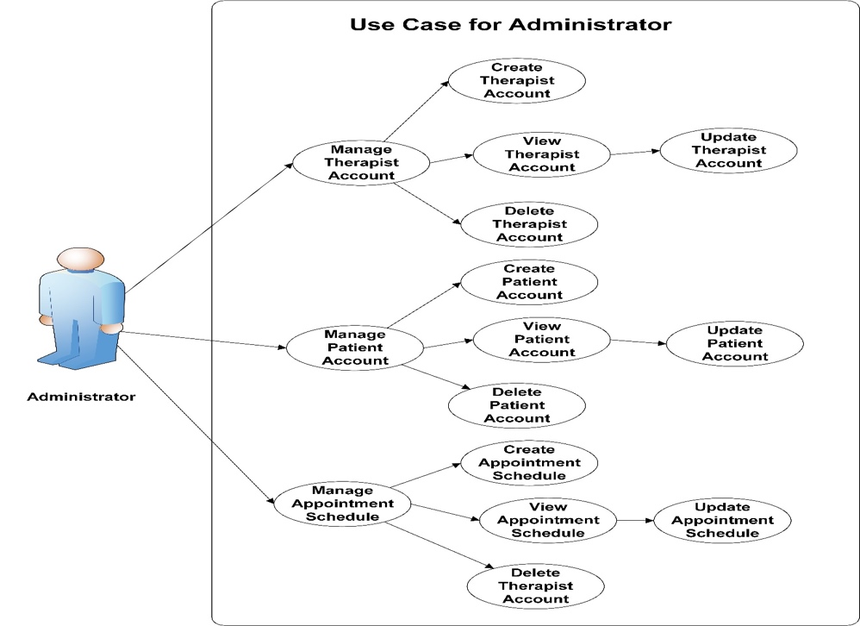

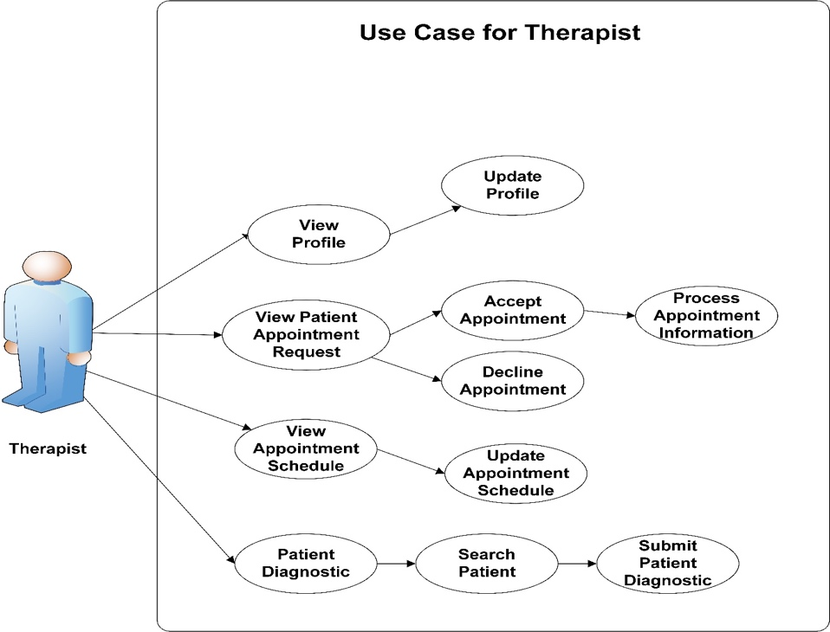Figure 3.11 Use Case Diagram for Administrator

Figure 3.12 Use Case Diagram for Therapist

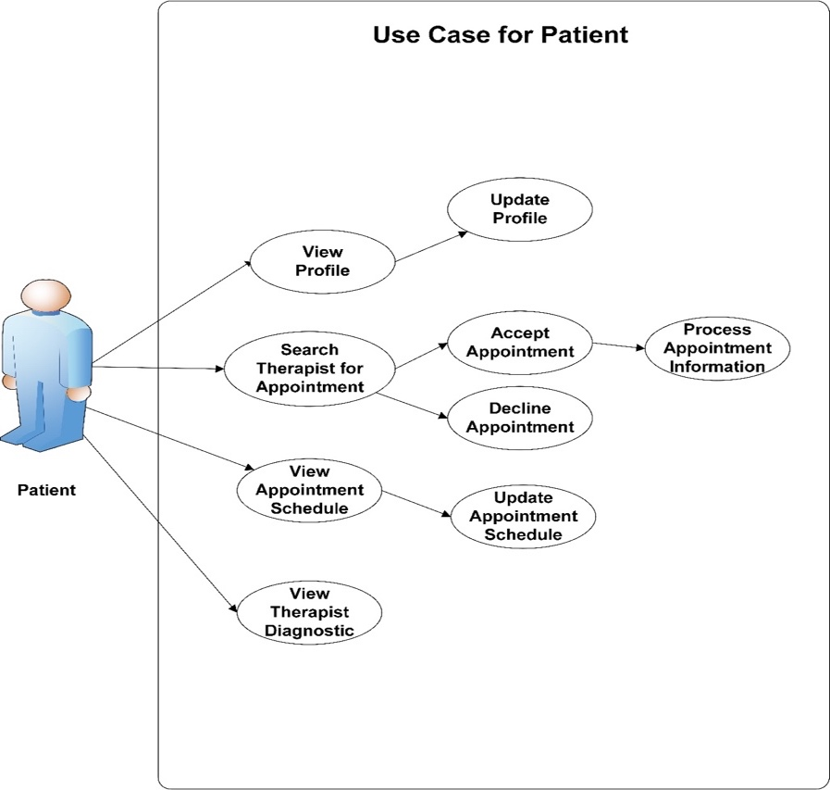

Figure 3.13 Use Case Diagram for Patient

Thesis guidelines will be followed to ensure consistency of the system. Open Web Application Security Project (OWASP) Security Parameters shall be implemented in developing the system. The software that will be used is open-source to make sure they are freely available for the proponents.

1. **Construction Iterations**

In this point, the proponents will create the system by analyzing the flow of data based on the DFD. The first phase has developed the database using MySQL to identify the different information needed. The database will be based on the ERD. The second phase has initialized the Online Registration Website, Appointment Scheduler with SMS Notification and Patient Dashboard where the local system has a fingerprint scanner to secure information of the patients. The system developed using PHP, JavaScript, MySQL, C#, .Net, HTML5.

Testing is done after each function is encoded to ensure proper execution of every function. Security parameters is be implemented using a checklist from Open Web Application Security Project (OWASP).

A Thesis meeting held each week to guarantee that the system will be finished on time. Updates also done constantly in Social Media in order to give quickness to the Project Managers decision-making process. Tasks are divided among the members to ensure that every part of the system will be fully functional.

Testing are conducted while the system started up and running, each button is tested by proponents to make sure the system is fully functioning.

1. **Transition: The "End Game"**

This phase started after all the modules are completed. Training of the users was also commenced in this phase. The proponents set a schedule to present the system to the management and IT Director. Once the system has been approved, the proponents set a schedule to train the end users. Parallel testing is being check the accuracy of the system and documents also be finalized with security parameters.

The system deployed to myasp.net a web hosting site that use Secure Socket Layer and Transfer Layer Security Protocols to ensure the availability and security of system online. Lastly, the Appointment Scheduler and Reminder using a WordPress Plugin “Bookly” that sends automated SMS Notification triggered by a new appointment the client has made.

Validation is done in iterative cycles to ensure the quality of the system. Additionally, every function of the code is tested again once the system is deployed to prevent any misusing of data.

1. **Production**

With the approval of the company management and with the end users trained for the use of the system, The Online Patient Portal with Secure Socket Layer and Human Resources Forecasting is in full operation. Any detects or enhancements that being identified are reported and documented. If there’s any changes that needs to be done on the system and the proponents is based on the discernment of the management.

Periodic backing up of the database are conducted to ensure that there is secure location where it can be recovered in the event of a natural disaster, hardware loss, or other emergency.

1. **Retirement**

If the capability of the system no longer addresses the business need of the company or if the functions have become obsolete, the system retired from production and migrated the users to another system. The proponents assist the management in transferring the database to the new system.